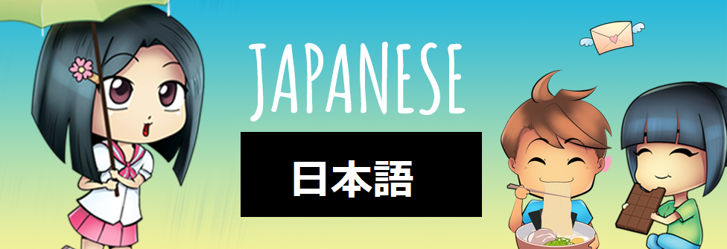

**St Paul’s Junior School Japanese Online Module: Yellow Belt 2020**

**YELLOW BELT SET 1**

**GOALS OF YELLOW BELT SET 1**

* To Learn Basic Japanese Greetings
* To be able to ask and respond to “How are you?” in Japanese
* To be able to read and write the first 5 Hiragana あいうえお and read combinations of those characters as small words

TEACHER USE ONLY: Goals Achieved - ２０２０年　 月　　日

 **STEP 1**: Instructions: Watch [OGENKI DESU KA Video](https://safeshare.tv/x/BVIHmiXxiak)

** STEP 2**: Go to [SET 1 FLASHCARDS](https://quizlet.com/78490896/flashcards) to help you fill in the blanks below:

|  |  |  |
| --- | --- | --- |
| Example: こんにちは | konnichi wa | Hello |
| おはよう | ohayou | **Good morning** |
| さようなら | sayounara | Click or tap here to enter text. |
| こんばんは | konban wa | Click or tap here to enter text. |
| おげんきですか。 | Ogenki desu ka. | Click or tap here to enter text. |
| げんきです。 | Genki desu. | Click or tap here to enter text. |
| まあまあです。 | Maa maa desu. | Click or tap here to enter text. |
| げんきじゃないです。 | Genki ja nai desu. | Click or tap here to enter text. |
| おやすみ | Oyasumi | Click or tap here to enter text. |
| もしもし | moshi moshi | Click or tap here to enter text. |

** Show Mr Mackenzie-Smith when you have finished Step 2**

** STEP 3: Watch this** [**VIDEO**](https://3ducation.wixsite.com/juniorjapanese/copy-of-yr-6-semester-1?wix-vod-video-id=dbeb9628f36b40399a938a238a5ccbf3&wix-vod-comp-id=comp-k6kj7ivo) **and then this** [**VIDEO**](https://3ducation.wixsite.com/juniorjapanese/copy-of-yr-6-semester-1?wix-vod-video-id=32dca3ead468431f9264cc57d88ff97e&wix-vod-comp-id=comp-k6kj7ivo)

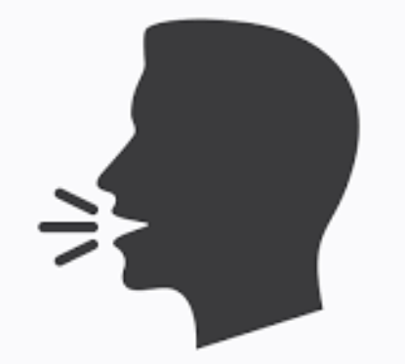**STEP 4: Ask Mr Mackenzie-Smith for a Set of Set 1 Flashcards and practise with a partner.**

* **1 partner takes turns saying the Japanese word and the other partner has to say the English word.**
* **Try and beat each other with your scores!** <https://quizlet.com/78490896/flashcards>

** STEP 5: Do Hiragana Practice Writing Sheet 1 (in your Hiragana Booklet) while watching this video:** [**https://safeshare.tv/x/ss5e5daa026d90d#**](https://safeshare.tv/x/ss5e5daa026d90d)

** Show Mr Mackenzie-Smith when you have finished the sheet.**

**STEP 6 : Play SET 1 QUIZIZZ :** <https://quizizz.com/join/quiz/5e4cf67e3ed5d4001b9ef671/start?from=soloLinkShare&referrer=55c299bcace092254e3c8441&startSource=link>

**STEP 7: Do the Hiragana Exercises (Vowel Line) in your Hiragana Writing Booklet**

** Show Mr Mackenzie-Smith when you have finished the sheet.**

**STEP 8: Do a survey of 5 class members, askng them: “Ogenki desu ka.” If they don’t understand, teach them the 3 responses: Genki desu , Maa maa desu , Genki ja nai desu. Fill in the table below:**

|  |  |  |
| --- | --- | --- |
|  | **名前　(Name)** | **O genki desu ka** |
| **1.** | **Type Name Here** | **Genki desu / Maa maa desu / Genki ja nai desu** |
| **2.** | **Type Name Here** | **Genki desu / Maa maa desu / Genki ja nai desu** |
| **3.** | **Type Name Here** | **Genki desu / Maa maa desu / Genki ja nai desu** |
| **4.** | **Type Name Here** | **Genki desu / Maa maa desu / Genki ja nai desu** |
| **5.** | **Type Name Here** | **Genki desu / Maa maa desu / Genki ja nai desu** |

**STEP 9: Do the Yellow Belt Set 1 Quiz at :** <https://learn.stpauls.qld.edu.au/mod/quiz/view.php?id=14713>

**STEP 10: Do the AIUEO “Colour the Hiragana” Exercise.**

** Show Mr Mackenzie-Smith when you have finished the sheet.**

**STEP 11: Do this A-O Hiragana Quiz:**

[**https://learn.stpauls.qld.edu.au/mod/quiz/view.php?id=14870**](https://learn.stpauls.qld.edu.au/mod/quiz/view.php?id=14870)

**FINAL TASK (YOU MUST DO THIS)**

**TO COMPLETE MODULE 1, YOU MUST UPLOAD IT**

**UPLOAD YOUR MODULE 1 (COMPLETED) TO THIS LINK** [**CLICK HERE**](https://learn.stpauls.qld.edu.au/mod/assign/view.php?id=14905)

**Completed on :**

**Teacher Use Only:**